**AZURE TAGS**

* For filtering the resources in Azure portal **tags** are used and best for cost purposes as well
* For each department in azure portal **tags** are maintained
* In Azure Portal we have plenty of resources for the azure subscription to figure out the resources which teams belongs to the resources we can use **tags**

**Storage Account (SA)** 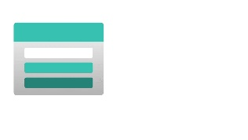

**What is Azure Storage:** Azure Storage is Microsoft's cloud storage solution for modern data storage scenarios.

Premium and standard

**What is Azure Storage Account:** Azure storage account contains all our storage data objects like blobs, files, queues, tables. The storage account provides a unique namespace for our Storage data that is accessible from anywhere in the world over HTTP or HTTPS.

1. Container/Blobs and Files are the main concepts on which Admin/infrastructure specialist works on.

2. Table and Queue storage are used and worked by Developers.

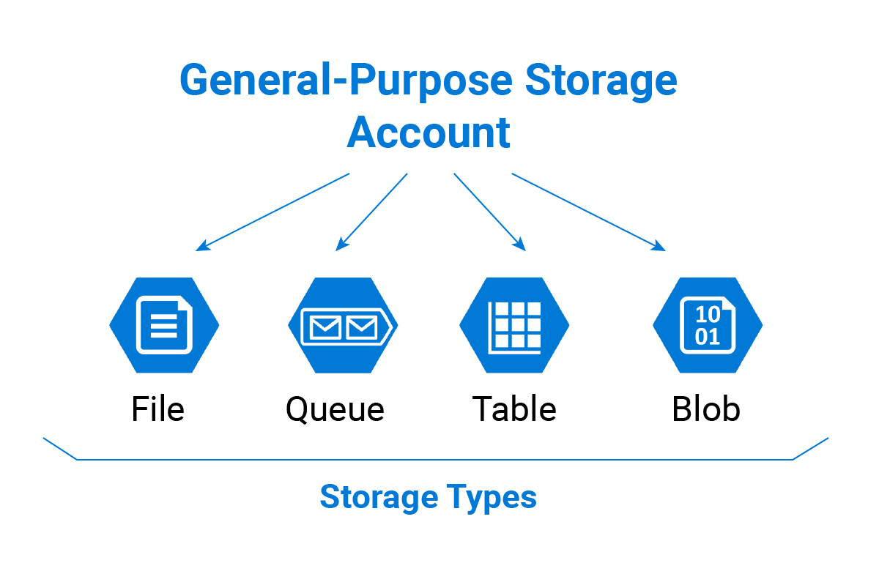

**Blob(Binary large object) :** It is used to store binary large objects, In blob we can store unstructured data and it is a part of storage service.

1. In Blob we have different types of storages. i.e.: (i)Page blob. (ii)append blob (iii)Block blob.
2. **Page blob:** it is used to keep the VM disks, the data which we are using very frequently keep under page blob, its pricing is cheaper then block blob
3. **Append blob:** Used for login purpose such as VM logs, diagnostics logs...etc.
4. **Block Blob:** It gives us the URL access of the data which helps us to keep the data such as docs, videos, images, pdf’s…etc.
5. Storage account (SA) is just a name space (or) place holder once we have or created a Storage Account (SA) then we will get the access of Blob/Queue/Table/Fileshare storages
6. When we are creating a Blob & file in Storage Account then we create a container, which is nothing but a folder.

**When we are creating a folder/container in blob then we have 3 options for public access level and i.e.: (i)Private (ii)Blob (iii)container.**

**(i)Private:** Only accessible to the owner/subscriber who has created the blob storage or accessible to the users whom the access has been granted by owner.

**(ii)Blob:** Means any person can read (blobs only, blobs means files only)blob is under the container, blob is just one file and container can have many blobs under it.

**(iii)container:** Anonymous read access for containers and blobs.

1. If we open the link in browser then after we upload the files/docs in Storage account(SA) for BLOB then the link is somewhat like this. https://azurestorageeacount12.blob.core.windows.net/sample/New Text Document.txt
2. **When we create a SA then we basically fills the below details.**

**(i)Subscription (ii)Resource Group (iii) Storage account name (iv)Location (v)performance : standard & premium (vi)Account kind (vii)Replication (viii) Access tier**

**Tier: HOT ; COOL ;ARCHIEVE**

**HOT ACCESS : This used for accessing more frequently( daily purposes)**

**Cool access : This is used for accessing infrequently (like monthly once or twice , weekly once or twice)**

**Archieve : This is used for longterm purposes (like if we want to aceess one year old data )**

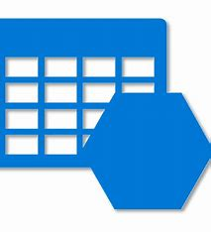**TABLE STORAGE**

1. **Table Storage:** these are used to keep No-Sql data, structure data but No-sql data, the database which is not relational that is called No-Sql data, SQL normally has relational DB that’s why we called as structure DB (or) Sql DB (or) Sql Data

* TO store non-relational structure data.

**QUEUE STORAGE**

1. **Queue Storage/Message Queue :** it is used to store the messages, if we want to store the messages in queue, we should use the developers tools, if we have a web facing interface (or) web facing application(or) web sites or front end server or Backend servers.
2. **Front end server:** responsible to acknowledge the request from users
3. **Backend server:** responsible to do the data processing

**QUEUE SERVICE IS A MESSAGING BASED SERVICES.**

 **FILE SHARE STORAGE**

1. **File Share Storage:** We create a file share and then we can help the users to map this file share with the team.
2. We can create a directory or folder in file share that we have created to any machine then it will give us an option to which o/s or machine we want to connect like(windows, Linux, MacOS) and this file share will map to our machine
3. [Azure Storage Explorer – cloud storage management | Microsoft Azure](https://azure.microsoft.com/en-in/products/storage/storage-explorer/)
4. **Azure storage explorer tool is used for copying the data**
5. **Replication:**  While creating a Storage account we have an option called replication and in replication we have 4-5 different types i.e.:

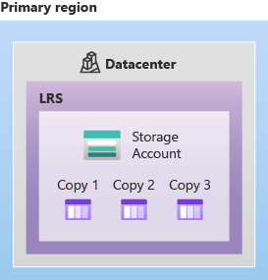

**(i)Locally Redundant Storage(LRS) >>**Here the data is going to kept in same region which we have selected. Here data is replicated 3 times and it gives SLA of 99.9 times 9. Here data gets replicated in same region what we have choose.

**SLA = SERVICE LEVEL AGREMENT**

**99.999999999999999999999 = 100%**

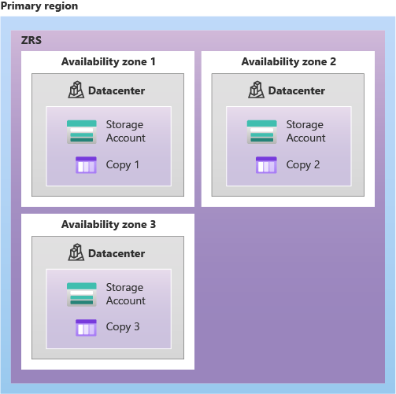

**(ii)zone redundant storage(ZRS) :** It gives an SLA of 99.12 times 9. It does the replication of data 3 times and this replication could be in same region or different region

**SLA = SERVICE LEVEL AGREMENT**

**99.999999999999999999999 = 100%**

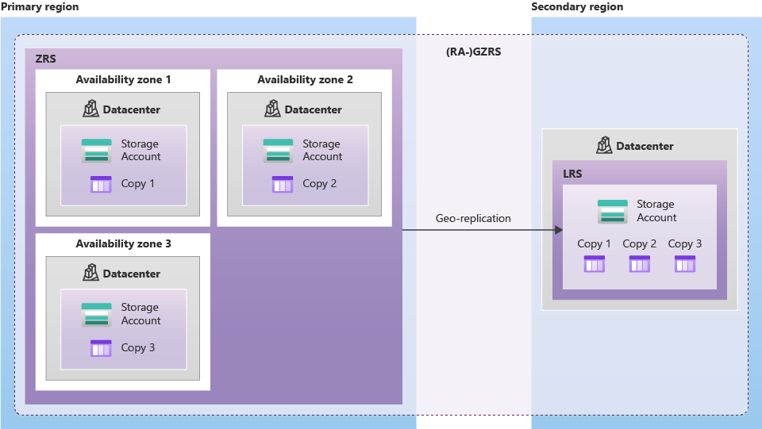

**(iii)Geo Redundant Storage(GRS) :** Here the data will get replicated 3 times in primary region and secondary region. It gives an SLA of 99.16 times 9.

**SLA = SERVICE LEVEL AGREMENT**

**99.999999999999999999999 = 100%**

1. **(iv)Read access geo redundant storage(RA-GRS) :** Here the data is replicated 3 times both in primary region and secondary region, but secondary region data is a ready only data
2. Storage account(SA) will keep the data of our VM
3. **Standard premium storage** account is used only for particular services like blob, files shares etc
4. Low latency (low network issues) is used for premium storage accounts
5. Access tiers is not available in premium storage accounts)hot ; cool achieve )

**WEB SERVERS**

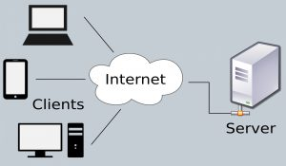

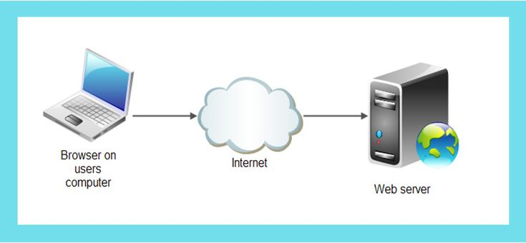

A web server is software and hardware that uses HTTP (Hypertext Transfer Protocol) and other protocols to respond to client requests made over the World Wide Web.

The main job of a web server is to display website content through storing, processing and delivering webpages to users. Besides HTTP, web servers also support SMTP (Simple Mail Transfer Protocol) and FTP (File Transfer Protocol), used for email, file transfer and storage.

Web server hardware is connected to the internet and allows data to be exchanged with other connected devices, while web server software controls how a user accesses hosted files.

More specifically, when a browser requests a page from a web server, the process will follow a series of steps.

* First, a person will specify a URL in a web browser's address bar.
* The web browser will then obtain the IP address of the domain name -- either translating the URL through [DNS](https://www.techtarget.com/searchnetworking/definition/domain-name-system) (Domain Name System)
* .This will bring the browser to a web server.
* The browser will then request the specific file from the web server by an HTTP request.
* The web server will respond, sending the browser the requested page, again, through HTTP.
* If the requested page does not exist or if something goes wrong, the web server will respond with an error message.
* The browser will then be able to display the webpage.

Multiple domains also can be hosted on one web server.

**Dynamic vs. static web servers**

A web server can be used to serve either static or dynamic content. Static refers to the content being shown as is, while dynamic content can be updated and changed

**Common and top web server software on the market**

* **Apache HTTP Server.** Developed by Apache Software Foundation, it is a free and open-source web server for Windows, Mac OS X, Unix, Linux, Solaris and other operating systems; it needs the Apache license.
* [Apache Tomcat® - Apache Tomcat 10 Software Downloads](https://tomcat.apache.org/download-10.cgi)
* **Microsoft Internet Information Services (IIS).** Developed by Microsoft for Microsoft platforms; it is not open sourced, but widely used.
* **Nginx.** A popular open-source web server for administrators because of its light resource utilization and scalability. It can handle many concurrent sessions due to its event-driven architecture. 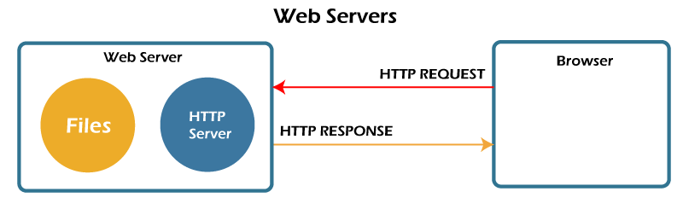

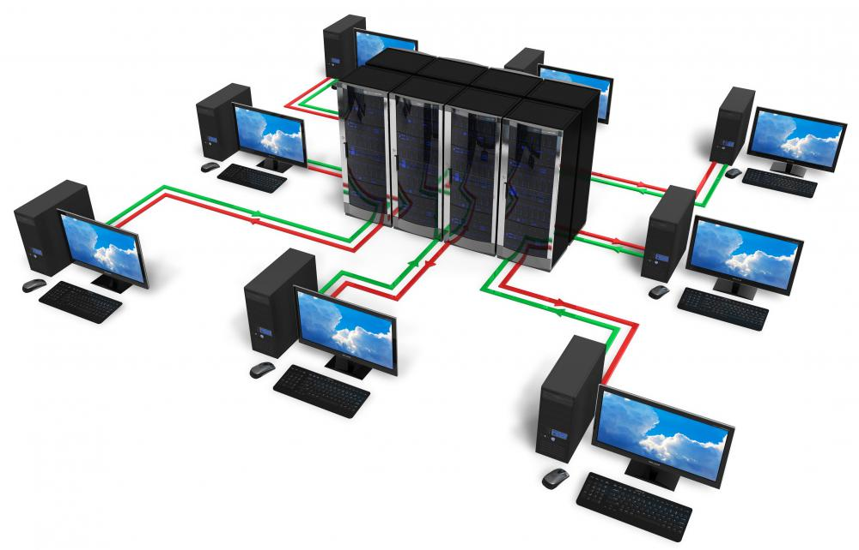

# **Azure architecture and services - Networking**

**Virtual Network:** 

**NETWORKING:** Interconnection of two or more computers in such a way so that can easily share the information

**Types of networks based on geographical area**

LAN = LOCAL AREA NETWORK

WAN = WIRLESS LOCAL AREA NETWORK

W LAN = WIDE AREA LOCAL NETWORK

MAN = METROPOLIAN AREA NETWORK

SAN = STORAGE AREA NETWORK

CAN = CAMPUS AREA NETWORK

PAN= PERSONAL AREA NETWORK

DAN = DESK AREA NETWORK

**Benefits of computer networking**:

* DATA SHARING
* VIDEO CONFERENCES
* ENHCANCE CONNECTIVITY
* INTERNET SERVICES
* SAVES MONEY
* EASES OUT MANAGEMENT OF DATA

An **Azure Virtual Network** (VNet) is a representation of your own **network** in the cloud. ... When we create a VNet, then all our services and VMs within our VNet can communicate directly and securely with each other in the cloud.

1. **Virtual network(Vnet):** It is basically an extension of our physical network, the resources like network, routing, switching….this all configuration is done by us, but it is being managed by our cloud provider.
2. All the devices in networking are managed by cloud provider but we are free to define our own network(n/w), free to create the address space, free to select the resource group, location, subnet….etc.
3. Basically we have 5 classes of IP’s. The 5 classes of IP is the first 5 Alphabet

i.e: (i)Class A (ii)Class B (iii) Class C (iv) Class D (v) Class E.

10.0.0.0 >> Class A

172.16.1.0 >> Class B

192.168.2.8>> Class C

1. The octet in IP address are separated by dot(.) Ex172.16.14.18

Here 172 is one octet 14 is one octet

16 is one octet 18 is one octet.

1. The Class D & Class E is useful for scientific and multicast purpose.
2. Generally we refer to Class A, B & C for our common use.
3. When we write an IP address with structure as 10.1.0.0/16(this /16 we call it as mask bits)
4. When we are following an IP address with mask bits such as /8, /16, /24 then it is called as Classful inter domain routing.
5. The pattern of IP address with **classful inter domain routing** is (i)10.2.8.16/8 (ii) 172.16.12.10/16 (iii) 192.56.23.10/24
6. The pattern of IP address with **classless inter domain routing** is (i)10.2.8.16/9 (ii) 172.16.12.10/11 (iii) 192.56.23.10/9
7. **Public IP address range for Class A, B & C as follows:**

**Class A :** 1.0.0.0 to 9.255.255.255 & 11.0.0.0 to 126.255.255.255

**Class B :** 128.0.0.0 to 172.15.255.255 & 173.32.0.0 to 191.255.255.255

**Class C :** 192.0.0.0 to 192.167.255.255 & 192.169.0.0 to 223.255.255.255

**Private IP address ranges for Class A,B, & C:**

**Class A:** 10.0.0.0 to 10.255.255.255

**Class B:** 172.16.0.0 to 172.31.255.255

**Class C :**`192.168.0.0 to 192.168.255.255

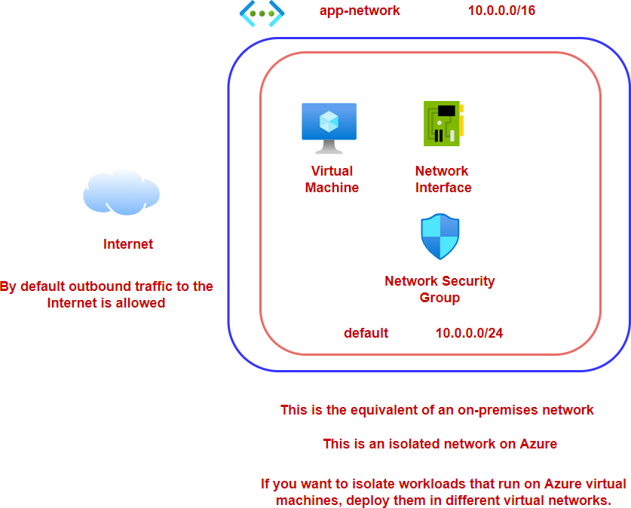

Communication across virtual machines in a virtual network

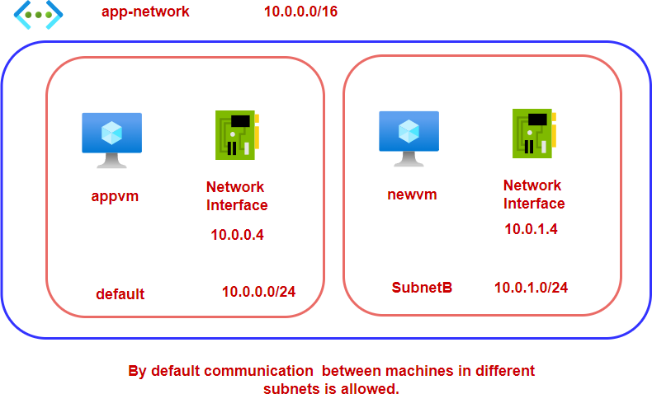



**5 Reserved Ip’s:**

**Example:**

* + - 10.0.0.0 -- > Network Address
    - 10.0.0.1 -- > Reserved by Azure for vpc router
    - 10.0.0.2 -- > Reserved by azure to IP address of DNS Server
    - 10.0.0.3 -- > Reserved for future use
    - 10.0.0.4 -- > Broadcast address

Network Security Groups



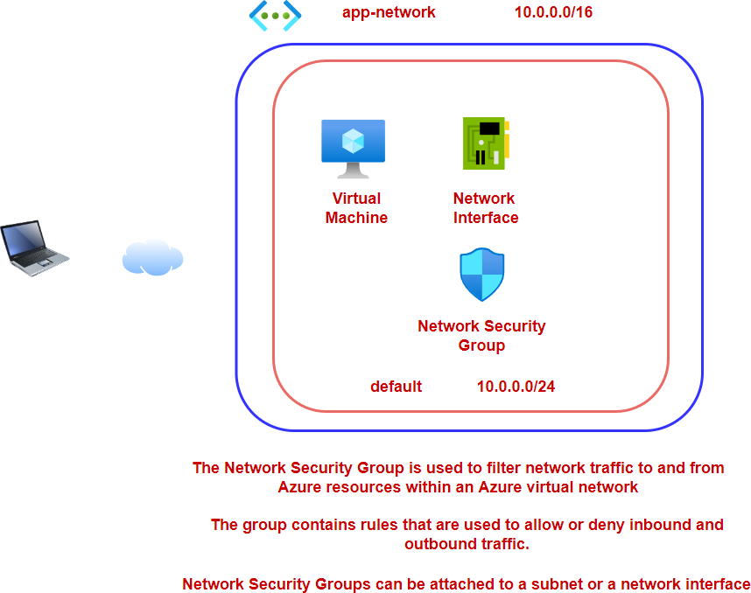

1. **Network Security Group(NSG):** Here we create the in-bound and out-bound traffic rules for our VM’s. once the VM gets created we will get both public and private IP addresses this IP addresses will get assign to our VM’s based upon the location/region we are choosing to create our VM, the IP addresses are defined based upon the geographic location.
2. In NSG we have an option to add inbound port rules and out bound port rules, application security groups, load balancing…etc.
3. **In-bound Port rule:** Here we are allowing the incoming traffic/inbound port rule to our VM Ex: which ports/services to allow which ports/services not to allow or deny…etc.
4. **Out-bound Port rule:** If the VM is trying to access an internet then basically it means it is trying to make an outbound rule/request, whether we want to allow or deny the outbound request by going through a particular port No, we have this liberty to modify this setting.

Hence in NSG we can do the setting for allowing (or) denying the ports of RDP/HTTP/HTTPS/FTP/SMTP/MSSQL/POSTGRESQL/LDAP…many as such



One resource from one Vnet and other resource from another Vnet will not be able to communicate with each other and to make them to communicate with each other we have to do the Vnet piering, Vnet piering is basically used to enable the communication from one Vnet resource to another Vnet resource

* **Vnet piering:** is considered as one of the option, We also have Vnet to Vnet connection as well, with which we can configure and enable to communicate resources from different Vnet.
* When we are creating subnet in Vnet then for sure the address prefix/spacing in the subnet should match with address space and then we can associate it.

. 